LAN SETUP INSTRUCTIONS

How to set up the projector for LAN usage:

The projector is shipped with a set of default settings, these are as follows:

Description | Value
IP address | 192.168.1.90
Subnet mask | 255.255.255.0
Default gateway | 192.168.1.1
TCP port | 1025
UDP port | 1225
Username | admin
Password | admin

Before you connect the projector to your LAN make sure that the IP address 192.168.1.90 is not already in use. If you need to change it, you have to make sure that the computer you use is on the same subnet. This means that the computer need to have an IP address in the range from 192.168.1.1 to 192.168.1.254.

If you need to change the computers IP address follow these steps:

- You have two options regarding how to make the physical connection to the projector. You can either use a crossover twisted pair (TP) cable directly from the computer to the projector, or two straight-through TP cables with a hub or switch between them.

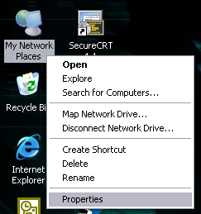

- When the connection is established, right click on ”Network Neighborhood” / ”My Network Places” and then click ”Properties”.

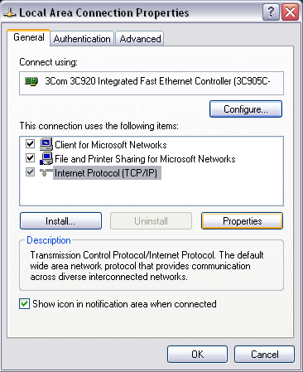

- First doubleclick on the network connection that represents your LAN, then doubleclick ”Internet Protocol (TCP/IP)”.

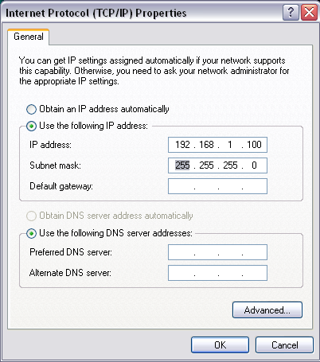

- On this screen you can set the computers IP address, make sure not to choose an address that’s already in use. Click OK on this and the previous dialog when you’re done.

Now the computer is on the same subnet as the projector, and you are ready to configure it. This is done by starting up an internet browser, like Internet Explorer or Opera and typing in the projectors default IP address (192.168.1.90) in the address bar.

You will then be presented with the login screen shown below:

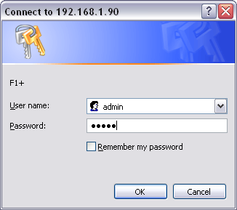

Here you type in the projectors default username and password (admin/admin). (Note: both username and password are case-sensitive.)

If both are correct you will see a configuration website like this:

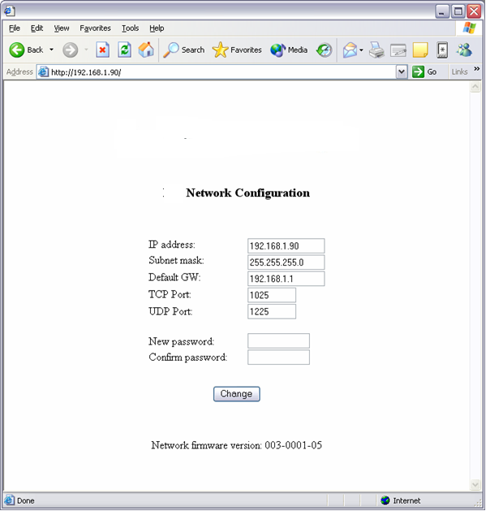

On this page you can setup the projectors IP address, subnet mask, default gateway, TCP port, UDP port and password. This page also displays which version of the network firmware the projector is running.

How to use the projectors LAN functionality:

Once the projector is setup correctly and connected to the LAN, it’s ready to receive commands. The LAN commands is exactly the same as for RS232 control, although you may have to pass on the commands to the projector with a different application.

HyperTerminal that comes with Windows, can be used for this.

- Start up HyperTerminal, click ”File” and then ”New Connection”. Give it a name and press OK. You will then see this dialog, here you choose TCP/IP (Winsock).

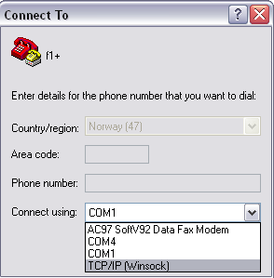

- Now type in the projectors IP address in the ”Host address:” field, and the projectors TCP port in the ”Port number:” field. Press OK when you’re done.
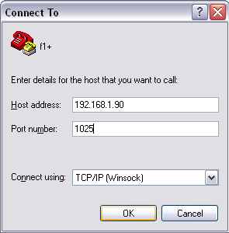

To send an eOperation to the projector, select ”Transfer” and then ”Send Text File...”.

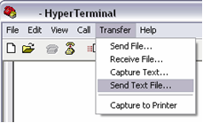

You will then be presented with a dialog which you can choose the file you want to transfer. Choose your command, click ”Open”, and the command will be transfered.

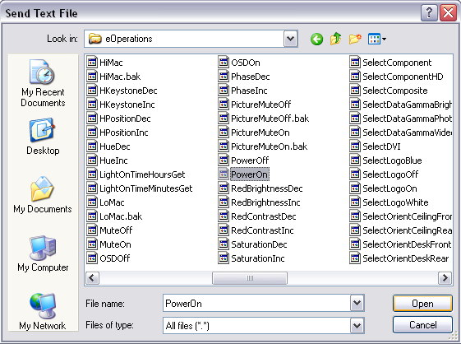

Other network options:

As you can see from the default settings table, the projectors also support commands over the UDP protocol. HyperTerminal doesn’t support UDP but there are other applications like the ones from SimpleComTools.

There is also quite easy to integrate this functionality if you are designing an application yourself.

With a Crestron, AMX and other control system you now have the option to control the projector via Ethernet in addition to RS232 using the same command set.

